**Introduction:**

* On premise data centre

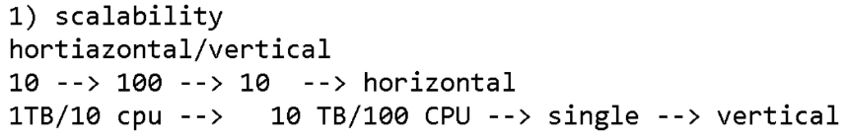

* Public cloud means anyone can request service or virtualization
* Private cloud means inside the organisation like banking which is confidential. They use some software to manage the own cloud inside the organisation
* Hybrid cloud is the combination of both public and private. For example, organisation have public cloud for testing or dev and private cloud is on premise data centre

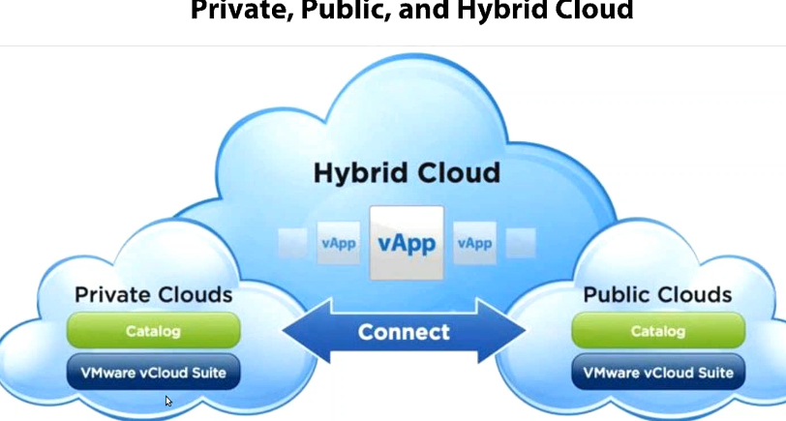

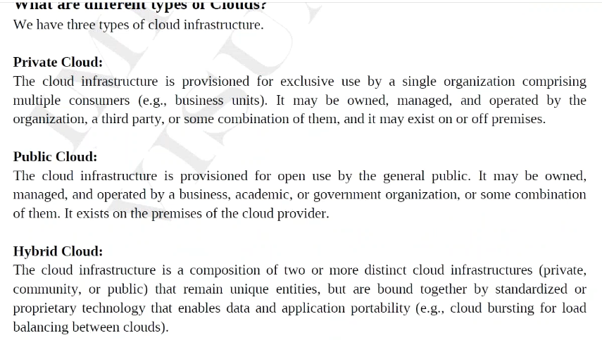

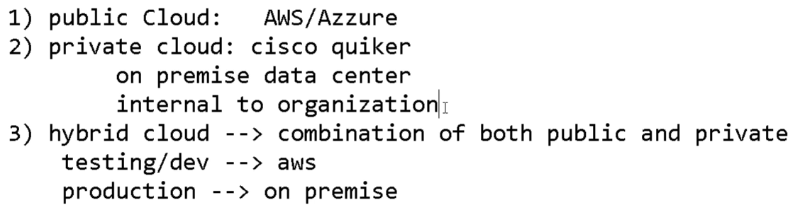

**Types of Cloud service models:**

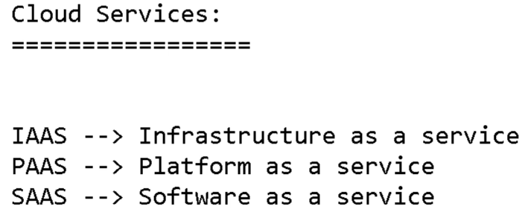

**SAAS:**

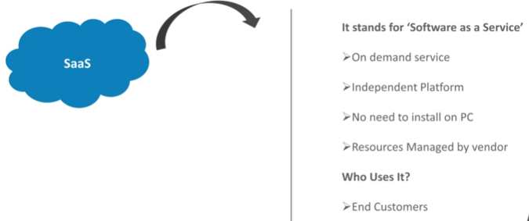

* SAAS is something we haven’t developed or maintain it. We are just accessing the software as a service by paying
* We no need to do anything with it, we just access in via internet
* Example: Gmail, FB etc. any other applications

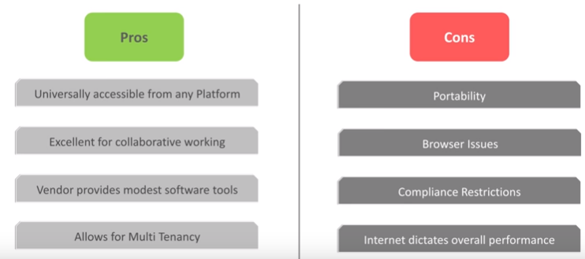

**PAAS:**

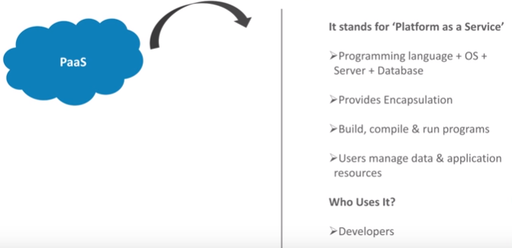

* PAAS is something for example, we developed something and use cloud engine just to manage the source code
* This means the provider will give the entire platform to you. The vendor will take care of all the backend. We take care of application and the data

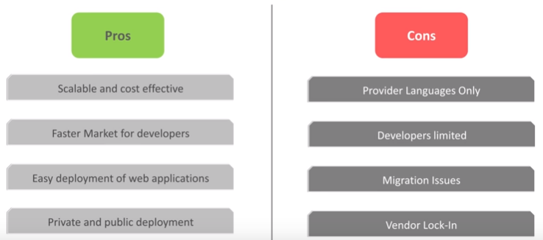

**IAAS:**

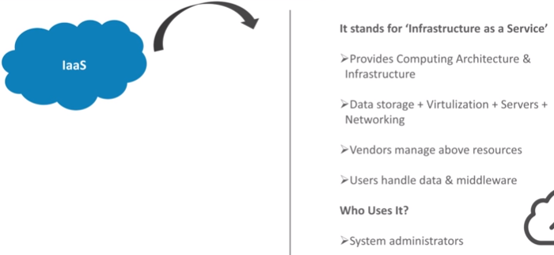

* IAAS is something they provide IP address of virtual machines, we login and build and use it for software. For example, AWS ec2
* Here infrastructure will be given to you and we need to build in the way we want to

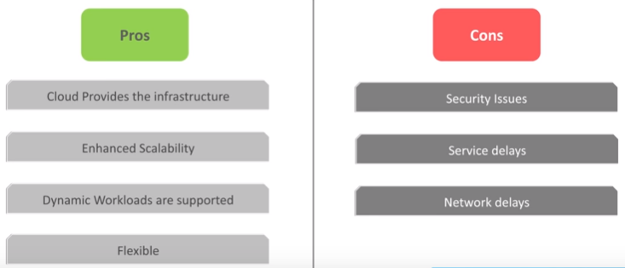

**Business model:**

